# iOS/Android User Push Notifications with Firebase Console Manual

* [Link to Firebase Documentation](https://firebase.google.com/docs/cloud-messaging/send-with-console)
* [Link to Notifications Firebase Manual](https://support.google.com/firebase/answer/6394759)
* You can send notification messages to iOS and Android devices using the [Notifications Composer](https://console.firebase.google.com/project/_/notification/compose) in the Firebase console
* After you have developed logic in your app to receive messages, you can allow non-technical users to send messages per the instructions in the [Notifications](https://support.google.com/firebase/answer/6394759) page in the Firebase Help Center.
* **About FCM message fields in the Notifications composer**
  + When you send a notification message from the [Notifications composer](https://console.firebase.google.com/project/_/notification/compose), Google uses the fields entered in the composer in two ways:
    - Fields like User segment and Expires determine the message target and delivery options.
    - Fields like Message text and Custom data are sent to the client in a payload comprised of key/value pairs.
  + These fields map to keys available through the FCM server protocols. For example, key/value pairs entered in Custom data are handled as a [data payload](https://firebase.google.com/docs/cloud-messaging/http-server-ref#data) for the notification. Other fields map directly to keys in the FCM [notification payload](https://firebase.google.com/docs/cloud-messaging/http-server-ref#notification-payload-support).
  + Note that some fields in the [Notifications composer](https://console.firebase.google.com/project/_/notification/compose) are *not* available through the FCM server protocols. For example, you can target user segments based on app, app version, language or user properties in ways that are not available using the to field in the server API.
* Keys that Firebase console sends to clients are:
  + 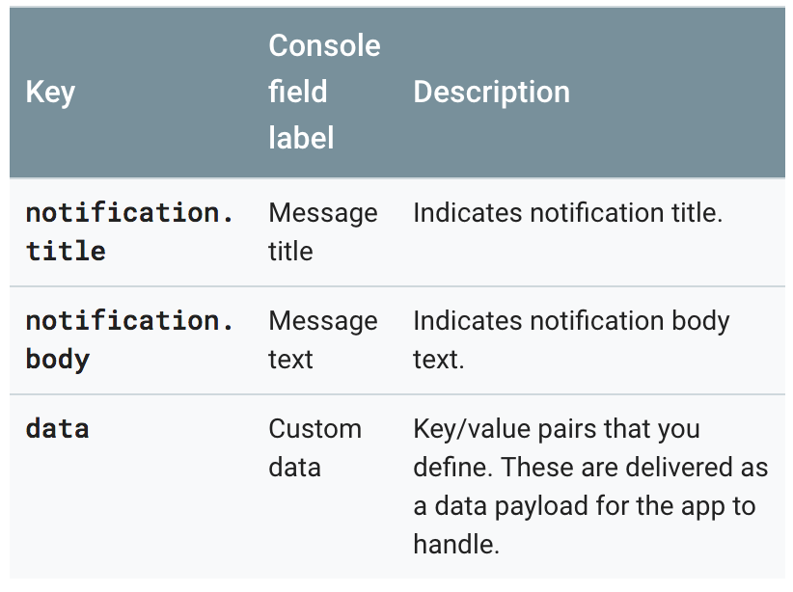
* Keys that determine message delivery include:
  + 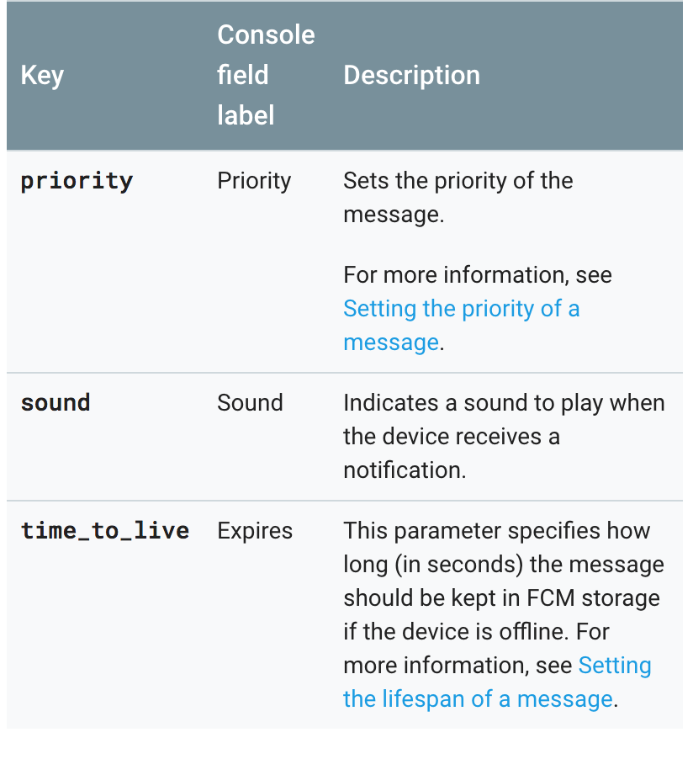
* Screenshots for Notifications in Firebase:
  + 
   